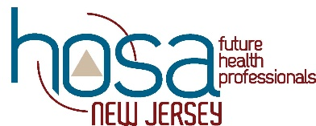

Regional Conference Competitive Events

PLEASE CHECK COMPETITIVE EVENT CODES CAREFULLY. The events and codes are in accordance with National HOSA’s 2023-2024 New Competitive Events Handbook Section B. These codes must be used for registration for the Regional, State and National competitive events. We may have to limit the number of competitors per event by chapter due to safety concerns based on the space available at the host sites. We will let all know as soon as we have finalized the site locations.

COMPETITIVE EVENT EVENT CODE

HEALTH SCIENCE EVENTS
Behavioral Health BH
Cultural Disparities & Diversity CDD
Dental Terminology DT
Human Growth and Development HGD
Medical Law and Ethics MLE
Medical Math MM
Medical Spelling (written test only at regional level) MS
Medical Terminology MT
Nutrition NUT
Pathophysiology PAT
Pharmacology PHA

HEALTH PROFESSIONS EVENTS
Dental Science DS
Home Health Aide HHA
Medical Assisting MA
Nursing Assisting NA
*Personal Care (Level 2) PC
Sports Medicine SM

EMERGENCY PREPAREDNESS EVENTS
CPR/First Aid (only (1) team per chapter) CPR
EMT (only (1) team per chapter) EMT
*Life Support Skills (Level 2) LSS

LEADERSHIP EVENTS
Extemporaneous Writing EW
*Interviewing Skills (Level 2) IS
Job Seeking Skills JS
Prepared Speaking PS
*Speaking Skills (Level 2) SS

*All Level 2 events require a Student Eligibility form which can be found in the event guidelines.
Please note that NJ HOSA does not offer every competitive event offered by National HOSA. Information for each competitive event can be found on the National HOSA web site: http://www.hosa.org/natorg/sectb/index.html.

